EXPT NO:3 | Designing Multivariate Patterns
DATE: 12.01.2026 | Designing Multivariate Patterns

PRE-LAB QUESTIONS (PROVIDE BRIEF ANSWERS TO THE FOLLOWING QUESTIONS)
- Why is multivariate analysis essential in real-world AI problems?
Multivariate analysis is essential because real-world AI problems involve multiple interacting variables rather than a single factor. It helps models understand relationships and dependencies among features. This leads to more accurate predictions and better decision-making. Analyzing variables together also reduces misleading conclusions. Hence, it reflects real-world complexity more effectively.
- What challenges arise when visualizing high-dimensional data?
Visualizing high-dimensional data is challenging because it cannot be directly represented in two or three dimensions. Reducing dimensions may cause loss of important information. Overlapping data points create visual clutter and confusion. Interpreting patterns becomes difficult as dimensions increase. Specialized techniques are required to handle these challenges.
- How does correlation analysis support feature selection?
Correlation analysis helps identify relationships between features and the target variable. It reveals redundant or highly correlated features that may not add new information. Removing such features simplifies the model. This improves training speed and reduces overfitting. It also enhances model interpretability.
- What are ethical concerns in healthcare data visualization?
Healthcare data visualization raises concerns about patient privacy and data security. Improper anonymization can expose sensitive information. Misleading or poorly designed charts may result in incorrect medical decisions. Biased representations can affect treatment outcomes. Ethical visualization ensures accuracy, fairness, and confidentiality.
- Give examples of multivariate data in AI systems.
Multivariate data is common in AI systems such as healthcare, where patient age, symptoms, and test results are analyzed together. Autonomous vehicles process sensor data, speed, and location simultaneously. Recommendation systems use user behavior, ratings, and time data. Fraud detection systems analyze multiple transaction attributes. All these systems rely on multiple variables to make decisions.
IN-LAB EXERCISE:
OBJECTIVE:
To discover relationships among multiple variables using multivariate visualization.
SCENARIO:
A hospital analytics team studies patient health records to identify relationships between age, BMI, glucose levels, and blood pressure for early disease prediction.

IN-LAB TASKS (Using R Language)
- Generate scatter plot matrix
- Apply color encoding for age groups
- Identify correlated health indicators

CODE:

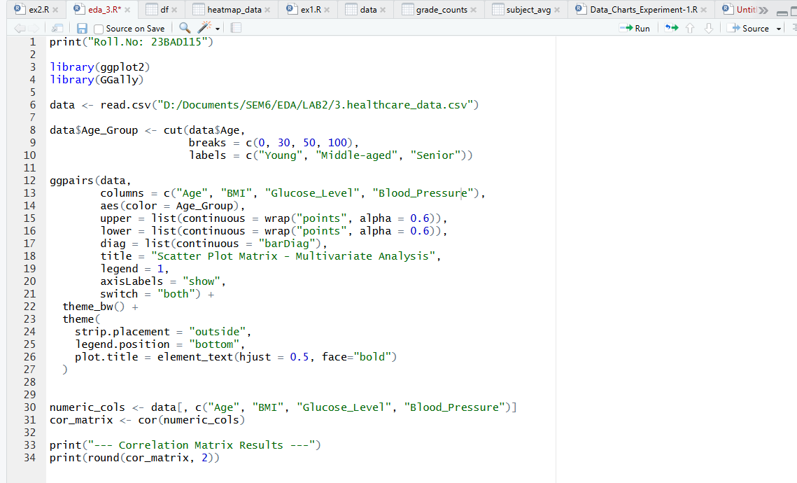
OUTPUT:
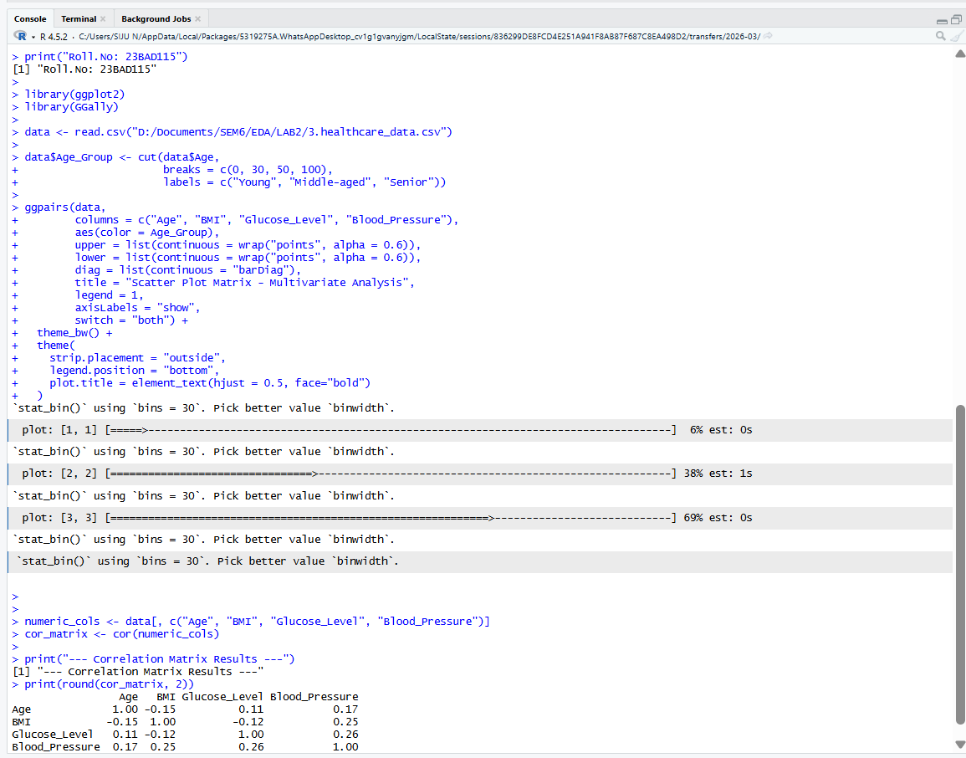
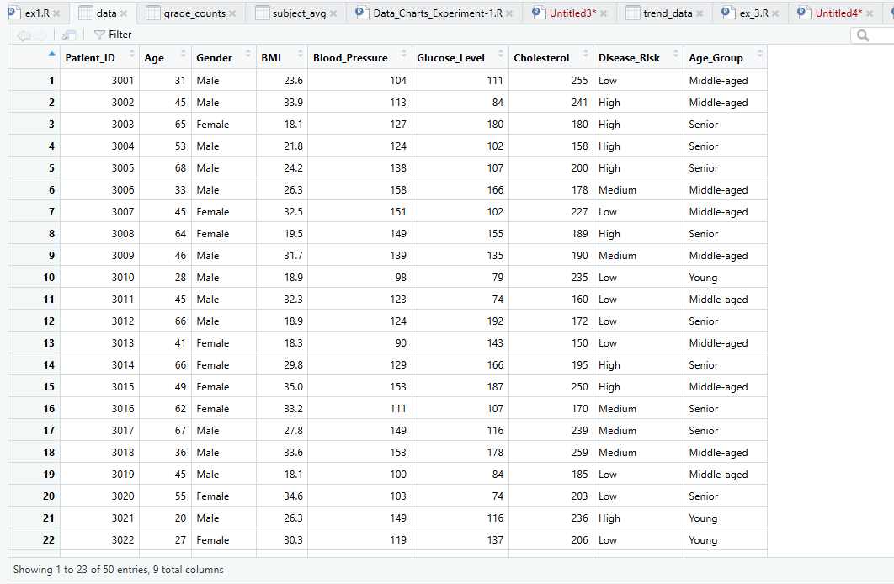

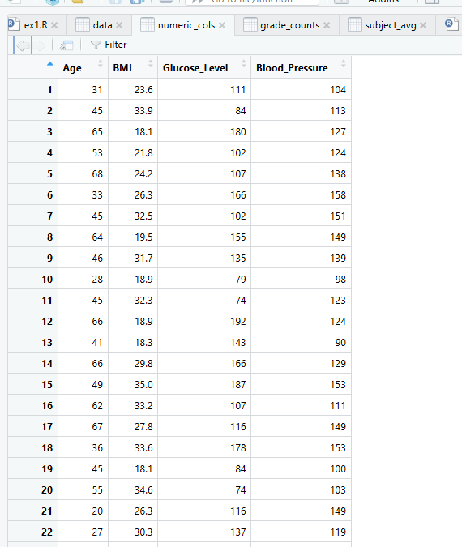

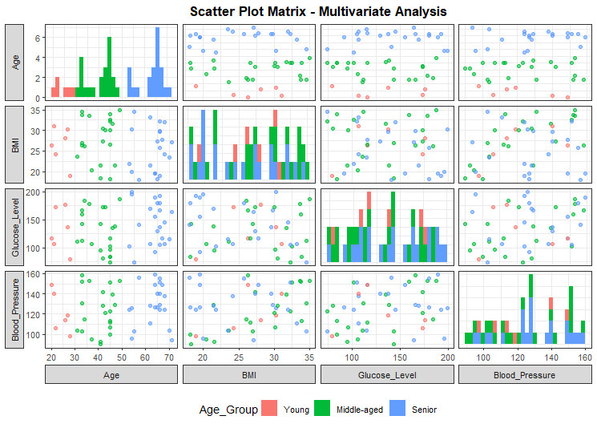

POST-LAB QUESTIONS (PROVIDE BRIEF ANSWERS TO THE FOLLOWING QUESTIONS)
- Which health parameters show strong correlation?
From the correlation matrix, Glucose Level and Blood Pressure (≈ 0.26) and BMI and Blood Pressure (≈ 0.25) show the relatively strongest positive correlations, though overall correlations are moderate to weak, indicating no extreme linear dependency.

- Why correlation does not imply causation in medical data?
Correlation only shows association, not cause–effect. In healthcare, variables may be influenced by hidden factors like lifestyle, genetics, or medication, so one parameter increasing does not necessarily cause another to change.

- How can these patterns assist predictive healthcare AI?
Identified relationships help AI models select relevant features, detect early risk patterns, and improve prediction accuracy for diseases such as diabetes or hypertension using multivariate inputs.

- What visualization limitations exist for high-dimensional data?
As dimensions increase, plots become cluttered and hard to interpret, making it difficult to observe clear relationships, trends, or interactions between many variables simultaneously.

- How can dimensionality reduction improve visualization?
Techniques like PCA reduce many variables into fewer meaningful components, preserving key patterns while enabling clearer 2D or 3D visualizations for better analysis and interpretation.

ASSESSMENT
Description | Max Marks | Marks Awarded
Pre Lab Exercise | 5
In Lab Exercise | 10
Post Lab Exercise | 5
Viva | 10
Total | 30
Faculty Signature

